
Transition Pack for A Level Chemistry


Get ready for A-level!
This resource is strictly for the use of member schools for as long as they remain members of The PiXL Club. It may not be copied, sold nor transferred to a third party or used by the school after membership ceases. Until such time it may be freely used within the member school.

All opinions and contributions are those of the authors. The contents of this resource are not connected with nor endorsed by any other company, organisation or institution.
www.pixl.org.uk The PiXL Club Ltd, Company number 07321607

A guide to help you get ready for A-level Chemistry, including everything from topic guides to days out and online learning courses.

Commissioned by The PiXL Club Ltd. February 2016

© Copyright The PiXL Club Ltd, 2016

Please note: these resources are non-board specific. Please direct your students to the specifics of where this knowledge and skills most apply.
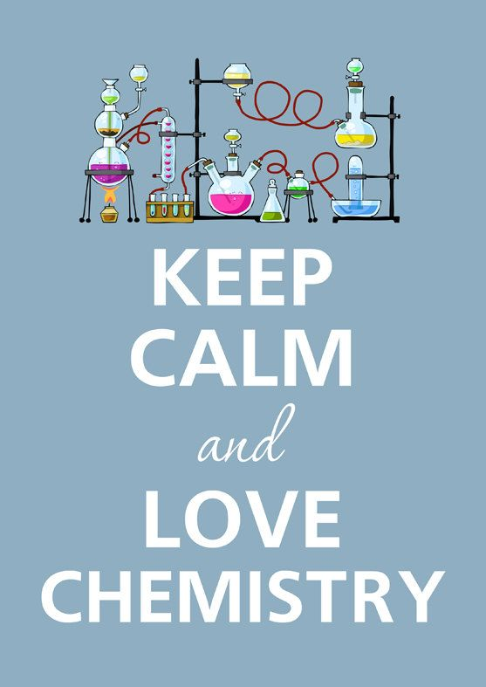
So you are considering A Level Chemistry?

This pack contains a programme of activities and resources to prepare you to start an A level in Chemistry in September. It is aimed to be used after you complete your GCSE, throughout the remainder of the summer term and over the Summer Holidays to ensure you are ready to start your course in September.

Book Recommendations
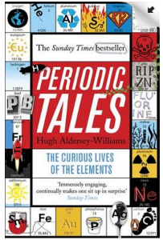
Periodic Tales: The Curious Lives of the Elements (Paperback) Hugh Aldersey-Williams
ISBN-10: 0141041455
http://bit.ly/pixlchembook1

This book covers the chemical elements, where they come from and how they are used. There are loads of fascinating insights into uses for chemicals you would have never even thought about.
The Science of Everyday Life: Why Teapots Dribble, Toast Burns and Light Bulbs Shine (Hardback) Marty Jopson
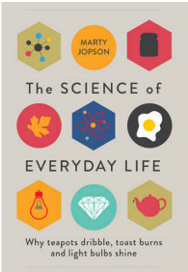
ISBN-10: 1782434186
http://bit.ly/pixlchembook2

The title says it all really, lots of interesting stuff about the things around you home!

Bad Science (Paperback) Ben Goldacre
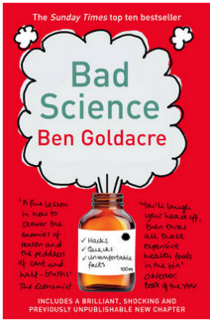
ISBN-10: 000728487X
http://bit.ly/pixlchembook3
Here Ben Goldacre takes apart anyone who published bad / misleading or dodgy science – this book will make you think about everything the advertising industry tries to sell you by making it sound ‘sciency’.

Calculations in AS/A Level Chemistry (Paperback) Jim Clark
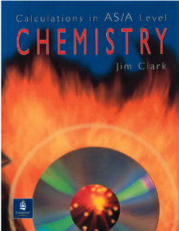
ISBN-10: 0582411270
http://bit.ly/pixlchembook4
If you struggle with the calculations side of chemistry, this is the book for you. Covers all the possible calculations you are ever likely to come across. Brought to you by the same guy who wrote the excellent chemguide.co.uk website.

Salters' Advanced Chemistry: Chemical Storylines
Do not feel you need to buy the latest edition (unless you are doing Salters chemistry!) You can pick up an old edition for a few pounds on ebay, gives you a real insight into how chemistry is used to solve everyday problems from global pollution through feeding to world to making new medicines to treat disease.
Videos to watch online
Rough science – the Open University – 34 episodes available
Real scientists are ‘stranded’ on an island and are given scientific problems to solve using only what they can find on the island.
Great fun if you like to see how science is used in solving problems.
There are six series in total
http://bit.ly/pixlchemvid1a
http://www.dailymotion.com/playlist/x2igjq_Rough-Science_rough-science-full-series/1#video=xxw6pr
or
http://bit.ly/pixlchemvid1b
https://www.youtube.com/watch?v=lUoDWAt259I
A thread of quicksilver – The Open University
A brilliant history of the most mysterious of elements – mercury. This program shows you how a single substance led to empires and war, as well as showing you come of the cooler properties of mercury.
http://bit.ly/pixlchemvid2
https://www.youtube.com/watch?v=t46lvTxHHTA
10 weird and wonderful chemical reactions
10 good demonstration reactions, can you work out the chemistry of …. any… of them?
http://bit.ly/pixlchemvid3
https://www.youtube.com/watch?v=0Bt6RPP2ANI
Chemistry in the Movies
Dantes Peak 1997: Volcano disaster movie.
Use the link to look at the Science of acids and how this links to the movie. http://www.open.edu/openlearn/science-maths-technology/science/chemistry/dantes-peak
http://www.flickclip.com/flicks/dantespeak1.html
http://www.flickclip.com/flicks/dantespeak5.html
Fantastic 4 2005 &2015: Superhero movie

Michio Kaku explains the “real” science behind fantastic four http://nerdist.com/michio-kaku-explains-the-real-science-behind-fantastic-four/

http://www.flickclip.com/flicks/fantastic4.html

Research activities
Use your online searching abilities to see if you can find out as much about the topic as you can. Remember it you are a prospective A level chemist, you should aim to push your knowledge.
You can make a 1-page summary for each one you research using Cornell notes:
http://coe.jmu.edu/learningtoolbox/cornellnotes.html
Task 1: The chemistry of fireworks
What are the component parts of fireworks? What chemical compounds cause fireworks to explode? What chemical compounds are responsible for the colour of fireworks?

Task 2: Why is copper sulfate blue?
Copper compounds like many of the transition metal compounds have got vivid and distinctive colours – but why?

Task 3: Aspirin
What was the history of the discovery of aspirin, how do we manufacture aspirin in a modern chemical process?

Task 4: The hole in the ozone layer
Why did we get a hole in the ozone layer? What chemicals were responsible for it? Why were we producing so many of these chemicals? What is the chemistry behind the ozone destruction?

Task 5: ITO and the future of touch screen devices
ITO – indium tin oxide is the main component of touch screen in phones and tablets. The element indium is a rare element and we are rapidly running out of it. Chemists are desperately trying to find a more readily available replacement for it. What advances have chemists made in finding a replacement for it?

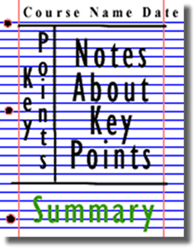

Figure 1: http://coe.jmu.edu/learningtoolbox/images/noteb4.gif
Pre-Knowledge Topics
Chemistry topic 1 – Electronic structure, how electrons are arranged around the nucleus
A periodic table can give you the proton / atomic number of an element, this also tells you how many electrons are in the atom.
You will have used the rule of electrons shell filling, where:
The first shell holds up to 2 electrons, the second up to 8, the third up to 8 and the fourth up to 18 (or you may have been told 8).
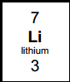
Atomic number =3, electrons = 3, arrangement 2 in the first shell and 1 in the second or
Li = 2,1
At A level you will learn that the electron structure is more complex than this, and can be used to explain a lot of the chemical properties of elements.

The ‘shells’ can be broken down into ‘orbitals’, which are given letters:’s’ orbitals, ‘p’ orbitals and ‘d’ orbitals.
You can read about orbitals here:
http://bit.ly/pixlchem1
http://www.chemguide.co.uk/atoms/properties/atomorbs.html#top

Now that you are familiar with s, p and d orbitals try these problems, write your answer in the format:
1s², 2s², 2p⁶ etc.
Q1.1 Write out the electron configuration of:
a) Ca b) Al c) S d) Cl e) Ar f) Fe g) V h) Ni i) Cu j) Zn k) As
Q1.2 Extension question, can you write out the electron arrangement of the following ions:
a) K⁺ b) O²⁻ c) Zn²⁺ d) V⁵⁺ e) Co²⁺

Chemistry topic 2 – Oxidation and reduction
At GCSE you know that oxidation is adding oxygen to an atom or molecule and that reduction is removing oxygen, or that oxidation is removing hydrogen and reduction is adding hydrogen. You may have also learned that oxidation is removing electrons and reduction is adding electrons.
At A level we use the idea of oxidation number a lot!
You know that the metals in group 1 react to form ions that are +1, i.e. Na⁺ and that group 7, the halogens, form -1 ions, i.e. Br -.
We say that sodium, when it has reacted has an oxidation number of +1 and that bromide has an oxidation number of -1.
All atoms that are involved in a reaction can be given an oxidation number.
An element, Na or O₂ is always given an oxidation state of zero (0), any element that has reacted has an oxidation state of + or -.
As removing electrons is reduction, if, in a reaction the element becomes more negative it has been reduced, if it becomes more positive it has been oxidised.

-5 0 +5
You can read about the rules for assigning oxidation numbers here:
http://www.dummies.com/how-to/content/rules-for-assigning-oxidation-numbers-to-elements.html


Elements that you expect to have a specific oxidation state actually have different states, so for example you would expect chlorine to be -1, it can have many oxidation states: NaClO, in this compound it has an oxidation state of +1
There are a few simple rules to remember:
Metals have a + oxidation state when they react.
Oxygen is ‘king’ it always has an oxidation state of -2
Hydrogen has an oxidation state of +1 (except metal hydrides)
The charges in a molecule must cancel.
Examples: Sodium nitrate, NaNO₃ sulfate ion, SO₄²⁻
Na +1 3x O²⁻ 4xO²⁻ and 2- charges ‘showing’
+1 -6 -8 -2
To cancel: N = +5 S = +6
Q2.1 Work out the oxidation state of the underlined atom in the following:
a) MgCO₃ b) SO₃ c) NaClO₃ d) MnO₂ e) Fe₂O₃ f) V₂O₅
g) KMnO₄ h) Cr₂O₇²⁻ i) Cl₂O₄

Chemistry topic 3 – Isotopes and mass
You will remember that an isotopes are elements that have differing numbers of neutrons. Hydrogen has 3 isotopes; $H_{1}^{1}$ $H_{1}^{2}$ $H_{1}^{3}$
Isotopes occur naturally, so in a sample of an element you will have a mixture of these isotopes. We can accurately measure the amount of an isotope using a mass spectrometer. You will need to understand what a mass spectrometer is and how it works at A level. You can read about a mass spectrometer here:


http://bit.ly/pixlchem3
http://www.kore.co.uk/tutorial.htm
http://bit.ly/pixlchem4
http://filestore.aqa.org.uk/resources/chemistry/AQA-7404-7405-TN-MASS-SPECTROMETRY.PDF

Q3.1 What must happen to the atoms before they are accelerated in the mass spectrometer?
Q3.2 Explain why the different isotopes travel at different speeds in a mass spectrometer.
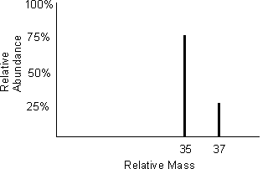
A mass spectrum for the element chlorine will give a spectrum like this:
75% of the sample consist of chlorine-35, and 25% of the sample is chlorine-37.
Given a sample of naturally occurring chlorine ¾ of it will be Cl-35 and ¼ of it is Cl-37. We can calculate what the mean mass of the sample will be:
Mean mass = 75 x 35 + 25 x 37 = 35.5
100 100
If you look at a periodic table this is why chlorine has an atomic mass of 35.5.
http://www.avogadro.co.uk/definitions/ar.htm
An A level periodic table has the masses of elements recorded much more accurately than at GCSE. Most elements have isotopes and these have been recorded using mass spectrometers.
GCSE A level
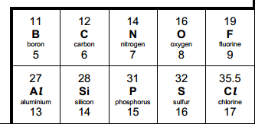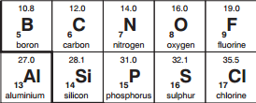
Given the percentage of each isotope you can calculate the mean mass which is the accurate atomic mass for that element.
Q3.3 Use the percentages of each isotope to calculate the accurate atomic mass of the following elements.
- Antimony has 2 isotopes: Sb-121 57.25% and Sb-123 42.75%
- Gallium has 2 isotopes: Ga-69 60.2% and Ga-71 39.8%
- Silver has 2 isotopes: Ag-107 51.35% and Ag-109 48.65%
- Thallium has 2 isotopes: Tl-203 29.5% and Tl-205 70.5%
- Strontium has 4 isotopes: Sr-84 0.56%, Sr-86 9.86%, Sr-87 7.02% and Sr-88 82.56%

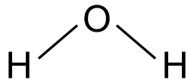
Chemistry topic 4 – The shapes of molecules and bonding.
Have you ever wondered why your teacher drew a water molecule like this?

The lines represent a covalent bond, but why draw them at an unusual angle?
If you are unsure about covalent bonding, read about it here:
http://bit.ly/pixlchem5
http://www.chemguide.co.uk/atoms/bonding/covalent.html#top

At A level you are also expected to know how molecules have certain shapes and why they are the shape they are.
You can read about shapes of molecules here:
http://bit.ly/pixlchem6
http://www.chemguide.co.uk/atoms/bonding/shapes.html#top
Q4.1 Draw a dot and cross diagram to show the bonding in a molecule of aluminium chloride (AlCl₃)
Q4.2 Draw a dot and cross diagram to show the bonding in a molecule of ammonia (NH₃)
Q4.3 What is the shape and the bond angles in a molecule of methane (CH₄)?

Chemistry topic 5 – Chemical equations
Balancing chemical equations is the stepping stone to using equations to calculate masses in chemistry.

There are loads of websites that give ways of balancing equations and lots of exercises in balancing.
Some of the equations to balance may involve strange chemical, don’t worry about that, the key idea is to get balancing right.
http://bit.ly/pixlchem7
http://www.chemteam.info/Equations/Balance-Equation.html
This website has a download; it is safe to do so:

http://bit.ly/pixlchem8
https://phet.colorado.edu/en/simulation/balancing-chemical-equations

Q5.1 Balance the following equations

a. H₂ + 0₂→ H₂0
b. S₈+ 02→ S0₃
c. HgO → Hg+ 0₂
d. Zn+ HCl→ ZnCl₂+ H₂
e. Na+ H₂0 → NaOH + H₂
f. C₁₀H₁₆+ CI₂ → C + HCl
g. Fe+ 0₂→ Fe₂0₃
h. C₆H₁₂0₆+ 0₂→ C0₂+ H₂0
i. Fe₂0₃ + H₂ → Fe + H₂0
j. Al + FeO → Al₂O₃ + Fe


Chemistry topic 6 – Measuring chemicals – the mole
From this point on you need to be using an A level periodic table, not a GCSE one you can view one here:
http://bit.ly/pixlpertab

https://secondaryscience4all.files.wordpress.com/2014/08/filestore_aqa_org_uk_subjects_aqa-2420-w-trb-ptds_pdf.png
Now that we have our chemical equations balanced, we need to be able to use them in order to work out masses of chemicals we need or we can produce.
The mole is the chemists equivalent of a dozen, atoms are so small that we cannot count them out individually, we weigh out chemicals.
For example: magnesium + sulfur → magnesium sulfide
Mg + S → MgS
We can see that one atom of magnesium will react with one atom of sulfur, if we had to weigh out the atoms we need to know how heavy each atom is.
From the periodic table: Mg = 24.3 and S = 32.1
If I weigh out exactly 24.3g of magnesium this will be 1 mole of magnesium, if we counted how many atoms were present in this mass it would be a huge number (6.02 x 10²³!!!!), if I weigh out 32.1g of sulfur then I would have 1 mole of sulfur atoms.
So 24.3g of Mg will react precisely with 32.1g of sulfur, and will make 56.4g of magnesium sulfide.
Here is a comprehensive page on measuring moles, there are a number of descriptions, videos and practice problems.

You will find the first 6 tutorials of most use here, and problem sets 1 to 3.
http://bit.ly/pixlchem9
http://www.chemteam.info/Mole/Mole.html
Q6.1 Answer the following questions on moles.
- How many moles of phosphorus pentoxide (P₄O₁₀) are in 85.2g?
- How many moles of potassium in 73.56g of potassium chlorate (V) (KClO₃)?
- How many moles of water are in 249.6g of hydrated copper sulfate(VI) (CuSO₄.5H₂O)? For this one, you need to be aware the dot followed by 5H₂O means that the molecule comes with 5 water molecules so these have to be counted in as part of the molecules mass.
- What is the mass of 0.125 moles of tin sulfate (SnSO₄)?
- If I have 2.4g of magnesium, how many g of oxygen(O₂) will I need to react completely with the magnesium? 2Mg +O₂ → MgO
Chemistry topic 7 – Solutions and concentrations
In chemistry a lot of the reactions we carry out involve mixing solutions rather than solids, gases or liquids.
You will have used bottles of acids in science that have labels saying ‘Hydrochloric acid 1M’, this is a solution of hydrochloric acid where 1 mole of HCl, hydrogen chloride (a gas) has been dissolved in 1dm³ of water.

The dm³ is a cubic decimetre, it is actually 1 litre, but from this point on as an A level chemist you will use the dm³ as your volume measurement.
http://bit.ly/pixlchem10
http://www.docbrown.info/page04/4_73calcs11msc.htm
Q7.1
- What is the concentration (in mol dm⁻³) of 9.53g of magnesium chloride (MgCl₂) dissolved in 100cm³ of water?
- What is the concentration (in mol dm⁻³) of 13.248g of lead nitrate (Pb(NO₃)₂) dissolved in 2dm³ of water?
- If I add 100cm³ of 1.00 mol dm³ HCl to 1.9dm³ of water, what is the molarity of the new solution?
- What mass of silver is present in 100cm³ of 1moldm⁻³ silver nitrate (AgNO₃)?
- The Dead Sea, between Jordan and Israel, contains 0.0526 moldm⁻³ of Bromide ions (Br ⁻), what mass of bromine is in 1dm³ of Dead Sea water?
Chemistry topic 8 – Titrations
One key skill in A level chemistry is the ability to carry out accurate titrations, you may well have carried out a titration at GCSE, at A level you will have to carry them out very precisely and be able to describe in detail how to carry out a titration - there will be questions on the exam paper about how to carry out practical procedures.

You can read about how to carry out a titration here, the next page in the series (page 5) describes how to work out the concentration of the unknown.
http://bit.ly/pixlchem11
http://www.bbc.co.uk/schools/gcsebitesize/science/triple_aqa/further_analysis/analysing_substances/revision/4/
Remember for any titration calculation you need to have a balanced symbol equation; this will tell you the ratio in which the chemicals react.
E.g. a titration of an unknown sample of sulfuric acid with sodium hydroxide.
A 25.00cm³ sample of the unknown sulfuric acid was titrated with 0.100moldm⁻³ sodium hydroxide and required exactly 27.40cm³ for neutralisation. What is the concentration of the sulfuric acid?
Step 1: the equation 2NaOH + H₂SO₄ → Na₂SO₄ + 2H₂O
Step 2; the ratios 2 : 1
Step 3: how many moles of sodium hydroxide 27.40cm³ = 0.0274dm³
number of moles = c x v = 0.100 x 0.0274 = 0.00274 moles
step 4: Using the ratio, how many moles of sulfuric acid
for every 2 NaOH there are 1 H₂SO₄ so, we must have 0.00274/2 =0.00137 moles of H₂SO₄
Step 5: Calculate concentration. concentration = moles/volume ←in dm³ = 0.00137/0.025 = 0.0548 moldm⁻³

Here are some additional problems, which are harder, ignore the questions about colour changes of indicators.
http://bit.ly/pixlchem12
http://www.docbrown.info/page06/Mtestsnotes/ExtraVolCalcs1.htm
Use the steps on the last page to help you
Q8.1 A solution of barium nitrate will react with a solution of sodium sulfate to produce a precipitate of barium sulfate.
Ba(NO₃)₂(aq) + Na₂SO₄(aq) → BaSO₄(s) + 2NaNO₃(aq)
What volume of 0.25moldm⁻³sodium sulfate solution would be needed to precipitate all of the barium from 12.5cm³ of 0.15 moldm⁻³ barium nitrate?

Chemistry topic 9 – Organic chemistry – functional groups

At GCSE you would have come across hydrocarbons such as alkanes (ethane etc) and alkenes (ethene etc). You may have come across molecules such as alcohols and carboxylic acids. At A level you will learn about a wide range of molecules that have had atoms added to the carbon chain. These are called functional groups, they give the molecule certain physical and chemical properties that can make them incredibly useful to us.
Here you are going to meet a selection of the functional groups, learn a little about their properties and how we give them logical names.
You will find a menu for organic compounds here:
http://bit.ly/pixlchem13
http://www.chemguide.co.uk/orgpropsmenu.html#top

And how to name organic compounds here:
http://bit.ly/pixlchem14
http://www.chemguide.co.uk/basicorg/conventions/names.html#top

Using the two links see if you can answer the following questions:
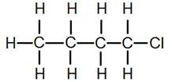
Q9.1 Halogenoalkanes
What is the name of this halogenoalkane?
How could you make it from butan-1-ol?
Q9.2 Alcohols
How could you make ethanol from ethene?
How does ethanol react with sodium, in what ways is this a) similar to the reaction with water, b) different to the reaction with water?
Q9.3 Aldehydes and ketones
Draw the structures of a) propanal b) propanone
How are these two functional groups different?
Chemistry topic 10 – Acids, bases, pH

At GCSE you will know that an acid can dissolve in water to produce H⁺ ions, at A level you will need a greater understanding of what an acid or a base is.
Read the following page and answer the questions
http://bit.ly/pixlchem15
http://www.chemguide.co.uk/physical/acidbaseeqia/theories.html#top
Q10.1 What is your new definition of what an acid is?
Q10.2 How does ammonia (NH₃) act as a base?

http://bit.ly/pixlchem16
http://www.chemguide.co.uk/physical/acidbaseeqia/acids.html#top
Q10.3 Ethanoic acid (vinegar) is a weak acid, what does this mean?
Q10.4 What is the pH of a solution of 0.01 moldm⁻³ of the strong acid, hydrochloric acid?

Pre-Knowledge Topics Answers to problems
Q1.1a) 1s² 2s² 2p⁶3s²3p⁶4s² b) 1s² 2s² 2p⁶3s²3p¹ c) 1s² 2s² 2p⁶3s²3p⁴ d) 1s² 2s² 2p⁶3s²3p⁵
e) 1s² 2s² 2p⁶3s²3p⁶ f) 1s² 2s² 2p⁶3s²3p⁶ 3d⁶4s² g) 1s² 2s² 2p⁶3s²3p⁶ 3d³4s²
h) 1s² 2s² 2p⁶3s²3p⁶ 3d⁸4s² i) 1s² 2s² 2p⁶3s²3p⁶ 3d¹⁰ 4s¹ j) 1s² 2s² 2p⁶3s²3p⁶ 3d¹⁰ 4s²
k) 1s² 2s² 2p⁶3s²3p⁶ 4s² 3d¹⁰ 4p³

Q1.2a) 1s² 2s² 2p⁶3s²3p⁶ b) 1s² 2s² 2p⁶3s²3p⁶ c) 1s² 2s² 2p⁶3s²3p⁶ 3d¹⁰
d) 1s² 2s² 2p⁶3s²3p⁶ e) 1s² 2s² 2p⁶3s²3p⁶ 3d⁷
==========================================================================================
Q2.1 a) +4 b) +6 c) +5 d) +4 e) +3 f) +5 g) +7 h) +6 i) +4
==========================================================================================
Q3.1 They must be ionised / turned into ions
Q3.2 The ions are all given the same amount of kinetic energy, as KE = ½ mv² the lighter ions will have greater speed / heavier ions will have less speed.
Q3.3 a) 121.855 b) 67.796 c) 107.973 d) 204.41 e) 87.710 / 87.7102

==========================================================================================
Q4.1
a) 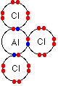 120º b) 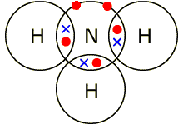107º c) 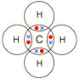109.5º

==========================================================================================

Q5a. 2H₂ + 0₂→ 2 H₂0
b. S₈+ 1202→ 8S0₃
c. 2HgO → 2Hg+ 0₂
d. Zn+ 2HCl→ ZnCl₂+ H₂
e. 2Na+ 2H₂0 → 2NaOH + H₂
f. C₁₀H₁₆+ 8CI₂ → 10C + 16HCl
g. 2Fe+ 30₂→ 2Fe₂0₃
h. C₆H₁₂0₆+ 60₂→ 6 C0₂+ 6 H₂0
i. Fe₂0₃ + 3H₂ → 2Fe + 3H₂0
j. 2Al + 3 FeO → Al₂O₃ + 3Fe

Q6.1 a) 85.2/284 = 0.3 moles b) 73.56/122.6 = 0.6 moles c) 249.5/249.5 = 1.0 moles
d) 0.125 x 212.8 = 26.6g e) 2Mg : 2O or 1:1 ratio 2.4g of Mg = 0.1moles so we need 0.1 moles of oxygen (O₂): 0.1 x 32 = 3.2g
7.1 a) 9.53g/95.3 = 0.1 moles, in 100cm³ or 0.1dm³ in 1dm³ 0.1moles/0.1dm³ = 1.0 mol dm⁻³
b) 13.284g/331.2 = 0.04 moles, in 2dm³ in 1dm³ 0.04moles /2dm³ = 0.02 mol dm⁻³
c) 100cm³ of 0.1 mol dm⁻³ = 0.01 moles added to a total volume of 2 dm³ = 0.01moles/2dm³ = 0.005 mol dm⁻³
d) in 1dm³ of 1 mol dm⁻³ silver nitrate, 1 mole of Ag = 107.9g in 0.1dm³ = 107.9 x 0.1 = 10.79g
e) 0.0526 x 79.7 = 42.0274g
==========================================================================================
8.1
Ba(NO₃)₂ : Na₂SO₄
1 : 1 ratio
12.5cm³ of Ba(NO₃)₂ = 0.0125dm³
0.15 moldm⁻³ x 0.0125dm³ = 0.001875 moles
same number of moles of sodium sulfate needed, which has a concentration of 0.25 mol dm⁻³
0.001875 moles / 0.25 mol dm⁻³ = 0.0075 dm³ or 7.5cm³
==========================================================================================
9.1 1-chlorobutane
Add butan-1-ol to concentrated HCl and shake
9.2 react ethene with hydrogen gas at high temperature and pressure with a nickel catalyst
The reaction is similar in that it releases hydrogen but different as it proceeds much slower than in water
9.3 propanal propanone
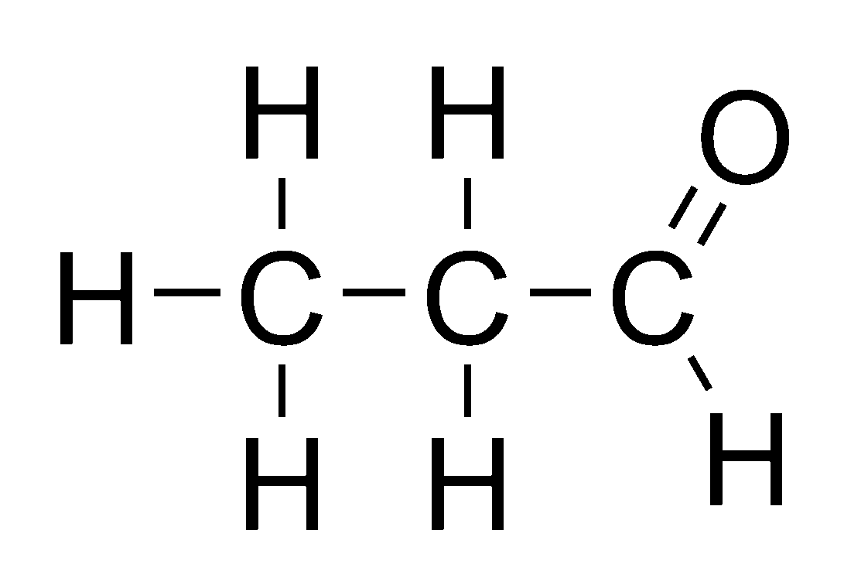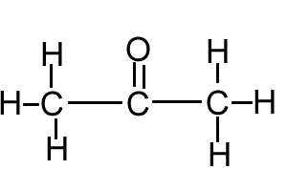
The carbon atom joined to oxygen in propanal has a hydrogen attached to it, it does not in propanone.
==========================================================================================
10.1 An acid is a proton donor
10.2 Ammonia can accept a proton, to become NH₄⁺
10.3 ethanoic acid has not fully dissociated, it has not released all of its hydrogen ions into the solution.
CH₃COOH ⇋ CH₃COO ⁻ + H⁺
Mostly this Very few of these
10.4 pH = -log [0.01] = 2 The pH = 2

Places to visit
- Go outdoors!
Have you actually spent any time observing the geology of the area you live in? What rocks or minerals are found in your area? Does your area have a history of extracting minerals? If so what were they, what were they used for, how did they obtain them? Are there any working or remains of mineral extraction industries?

- Are there any chemical or chemistry based businesses in your area? A big ask, but one that could be really beneficial to you, write them a letter explaining that you are taking A level chemistry and you want to see how chemistry is used in industry and you would like to visit / have some work experience. You never know this could lead to great things!!!!

- You could also try writing to / searching for your nearest university to see if they are running any summer schools for chemistry – they are usually free and give you the opportunity to experience the laboratories in a university.

- Science museums.
You could visit your nearest science museum. They often have special exhibitions that may be of interest to you.
https://en.wikipedia.org/wiki/List_of_science_museums#United_Kingdom

- Somerset Earth Science Centre:
http://www.earthsciencecentre.org.uk
- The UK Association for Science and Discovery Centres (ASDC)
This association brings together over 60 major science engagement organisations in the UK.
http://sciencecentres.org.uk/centres/weblinks.php

Chemistry A level transition - baseline assessment. 40 marks
All data is given on this paper, you will not need a periodic table
Answer all questions.
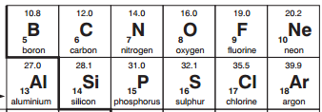
- Here is part of a periodic table, use it to answer the following questions

  - Which is the correct electron configuration for a nitrogen atom, circle the correct answer [1]

1s²2p⁵ 1s¹2p⁶ 1s²2s²2p³ 1s²2s⁵ 1s²2s²2p⁶3s²3p²
  - Which is the correct electron configuration for a chlorine atom, circle the correct answer [1]

1s²2s⁸2p⁷ 1s²2s²2p⁸2d⁵ 1s²2s²2p⁶3d⁷ 1s²2s²2p⁶3p⁷ 1s²2s²2p⁶3s²3p⁵
  - Which is the correct electron configuration for an aluminium ion, Al³⁺? Circle the correct answer [1]

1s²2s²2p⁶ 1s²2s²2p⁶3s²3p³ 1s²2s²2p⁶3s² 1s²2s²2p⁶2d¹
- Draw a dot and cross diagram to show the bonding in a molecule of water, H₂O. [2]
Atomic numbers: H =1, O =8

- A time of flight mass spectrometer has 4 main stages. put the correct stage in the diagram below:
Drift region Ionisation Detector Acceleration
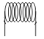

[4]
- A mass spectrometer was used to analyse a sample of chlorine; the results of the analysis are as follows:
isotope mass | % of sample
Cl-35 | 75.53
Cl-37 | 24.47

Calculate the accurate atomic mass of chlorine. Give your answer to 3 decimal places. [3]

mass: _______________________

- Give the oxidation state of the underlined atom in the following chemicals.
Useful information: H = +1, K = +1, Na = +1, Mg = +2, O = -2, Cl = -1 [7]

a) CO₂ b) SO₃ c) H₂SO₄ d) AlCl₃

e) Cr₂O₃ f) NaNO₃ g) VCl₄

- Balance the following chemical equations:

a) C₃H₈ + ___ O₂ → ___ CO₂ + ___ H₂O [3]

b) ___ HCl + Mg(OH)₂ → MgCl₂ + ___ H₂O [2]

c) Na₂CO₃ + ___ HCl → ___ NaCl + ___ H₂O + CO₂ [3]

- Calculate the relative formula masses of the following:
Atomic masses: H = 1, O = 16, S = 32.1, C = 12, Ca = 40.1, Na = 23, Cl = 35.5, Zn = 65.4

a) CaCl₂ b) H₂CO₃ c) Na₂SO₄ d) C₃H₇OH e) Zn(NO₃)₂ [5]

- A student carried out a reaction with this molecule:
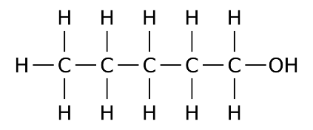 a. What is the name of this molecule? __________________ [2]

- Vinegar is a solution of ethanoic acid (CH₃COOH) in water. A student carried out a titration of a sample of vinegar.
He used a pipette to measure exactly 25.0cm³ of vinegar into a flask, added an indicator and titrated it with a 1.00 mol dm⁻³ solution of sodium hydroxide (NaOH).
The reaction is:
CH₃COOH + NaOH → CH₃COONa + H₂O

The student found that his average titration was 27.50cm³

c = n/v c = concentration (mol dm⁻³), n = number of moles, v = volume (dm³)

n = m/Rfm n = number of moles, m = mass in grams, Rfm = formula mass

1dm³ = 1000 cm³

- Using the chemical equation, how many moles of sodium hydroxide will react with 1 mole of ethanoic acid?

___________moles [1]

- How many moles of sodium hydroxide are in 27.50cm³ of 1.00 moldm⁻³ sodium hydroxide?

___________moles [2]

- How many moles of ethanoic acid are in 25.0cm³ of the vinegar sample?

___________moles [1]

- How many moles of ethanoic acid are in 1dm³ of vinegar?

___________moles [1]

- Ethanoic acid has a formula mass of 48. What mass of ethanoic acid is present in 1dm³ of vinegar?

___________g [2]

Chemistry A level transition - baseline assessment. - Answers
- .
  - Which is the correct electron configuration for a nitrogen atom, circle the correct answer [1]

1s²2p⁵ 1s¹2p⁶ 1s²2s²2p³ 1s²2s⁵ 1s²2s²2p⁶3s²3p²
  - Which is the correct electron configuration for a chlorine atom, circle the correct answer [1]

1s²2s⁸2p⁷ 1s²2s²2p⁸2d⁵ 1s²2s²2p⁶3d⁷ 1s²2s²2p⁶3p⁷ 1s²2s²2p⁶3s²3p⁵
  - Which is the correct electron configuration for an aluminium ion, Al³⁺? Circle the correct answer [1]

1s²2s²2p⁶ 1s²2s²2p⁶3s²3p³ 1s²2s²2p⁶3s² 1s²2s²2p⁶2d¹
- Draw a dot and cross diagram to show the bonding in a molecule of water, H₂O. [2]
Atomic numbers: H =1, O =8
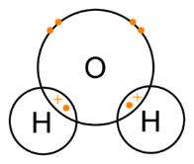
1 mark for 2 x shared electrons
1 mark for lone pairs

- A time of flight mass spectrometer has 4 main stages. put the correct stage in the diagram below:
Drift region
Ionisation

[4]
Acceleration
Detector

- A mass spectrometer was used to analyse a sample of chlorine, the results of the analysis are as follows:
(35x75.53) + (37x24.47)/100 [1]
= 35.4894 [1]
To 3dp = 35.489 [1] [2 marks if above line is missing]
isotope mass | % of sample
Cl-35 | 75.53
Cl-37 | 24.47
[3]
- Give the oxidation state of the underlined atom in the following chemicals.
Useful information: H = +1, K = +1, Na = +1, Mg = +2, O = -2, Cl = -1 [7]

a) CO₂ +4 b) SO₃ +6 c) H₂SO₄ +6 d) AlCl₃ +3

e) Cr₂O₃ +3 f) NaNO₃ +5 g) VCl₄ +4

- Balance the following chemical equations:

a) C₃H₈ + _5_ O₂ → _3_ CO₂ + _4_ H₂O [3]

b) _2_ HCl + Mg(OH)₂ → MgCl₂ + _2_ H₂O [2]

c) Na₂CO₃ + _2_ HCl → _2_ NaCl + _1_ H₂O + CO₂ [3]

- Calculate the relative formula masses of the following:
Atomic masses: H = 1, O = 16, S = 32.1, C = 12, Ca = 40.1, Na = 23, Cl = 35.5

a) CaCl₂ b) H₂CO₃ c) Na₂SO₄ d) C₃H₇OH e) Zn(NO₃)₂ [5]
111.1 62 142.3 60 189.4
- A student carried out a reaction with this molecule:
a. What is the name of this molecule? pentan-1-ol [2]

Pentanol = 1 mark pentan-1-ol = 2 marks

- Using the chemical equation, how many moles of sodium hydroxide will react with 1 mole of ethanoic acid?

_____1_____moles [1]

- How many moles of sodium hydroxide are in 27.50cm³ of 1.00 moldm⁻³ sodium hydroxide?
27.5/1000 [1] x 1.00 = 0.0275 [1]
0.0275 [2] moles [2]

- How many moles of ethanoic acid are in 25.0cm³ of the vinegar sample?

___0.0275 __moles [1]

- How many moles of ethanoic acid are in 1dm³ of vinegar?
0.0275 x 1000/25 = 1.10

___1.10____moles [1]

- Ethanoic acid has a formula mass of 48. What mass of ethanoic acid is present in 1dm³ of vinegar?
1.1 x 48 = 52.8g

___52.8g ___g [1]

