Synergy Student Portal/Office 365 Single Sign-on
For years 7-10

Step 1.) Active Microsoft 365/Onedrive
If you haven’t done this step already, visit www.office.com and log in using your full school email address and password. There is a guide here if you haven’t used the Office 365/One Drive service before.

Step 2.) Log-in to Synergy
The Synergy Student Portal allows students to easily see what homework has been assigned by class teachers for each of their timetabled lessons.
To sign in visit https://thedeanery.schoolsynergy.co.uk/ and click ‘Staff/Student SSO’.
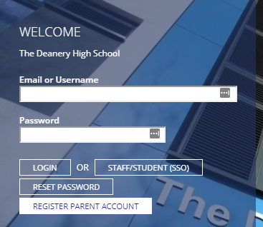

You will then be forwarded to the Microsoft Office 365 log in page. Log in using your full school email address (e.g. 23BloggsJo@deanery.wigan.sch.uk) and password. Allow any permissions they Synergy requests to access your Office 365 account.

Your Synergy Student Portal homepage will then load.
This is your Synergy Student Portal Homepage.
Here you can easily track what work has been set by your class teachers under ‘My Homework Due’.
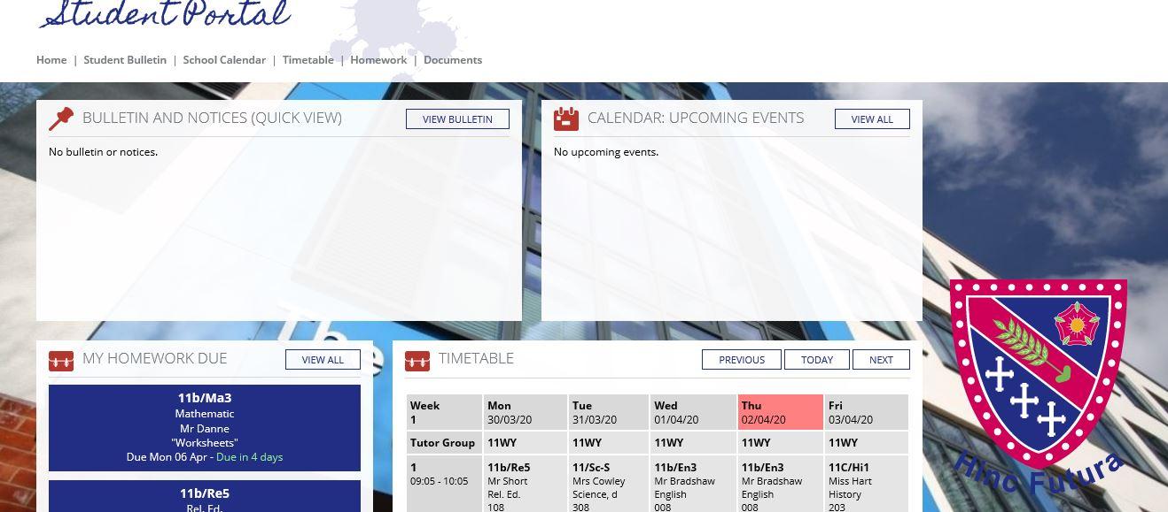

Click on a task to view its details and deadline. As you are also signed in to Office 365, you can easily click on links to documents and images relating to the work that has been set.
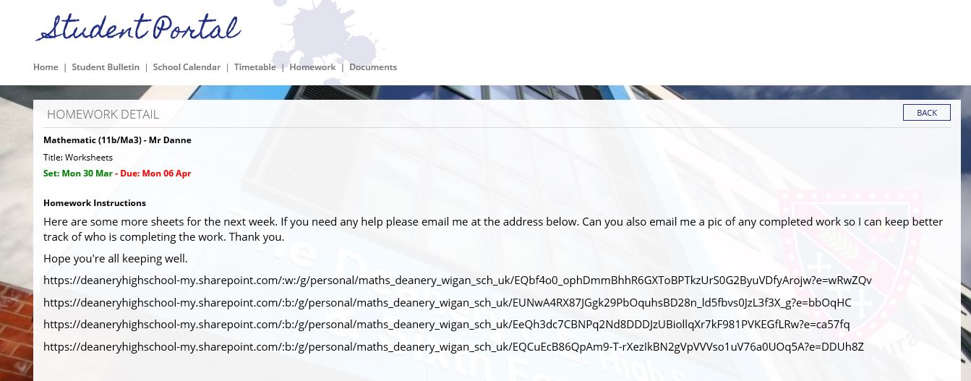
You can easily see previous work that has been set by adjusting the week view on your homework schedule by clicking ‘next’ or ‘previous’.
