Media Studies Email to applicants (Mr Nestor)

Good Morning,

We are delighted that you have taken an interest in studying A-Level Media Studies at the Deanery Sixth Form College. We are proud to have a consistent 100% pass rate, an increasing number of students achieving higher grades and, as a college, the highest “value added” for students completing academic subjects of any college in the Wigan area. The Media Studies pass rates for the most recent cohort were 100% A-B at AS Level, and 100% A-B at A2 level, and we are looking forward to you being a part of our future success.

As you now find yourself in the unprecedented situation of continuing your studies at home, we would like to offer you the benefit of making some preparations for your course by accessing the Media Studies Bridging Unit designed by myself, specifically tailored to support you in your beginning our A-Level Media Studies course.

This can be accessed at http://www.deanery.wigan.sch.uk/bridging-units/, similarly to the Bridging Units for your other subject choices. If you do happen to want more information, I'm more than happy to give you some tips on how to get a head start on some of the topics and theories that we will be doing once we start.
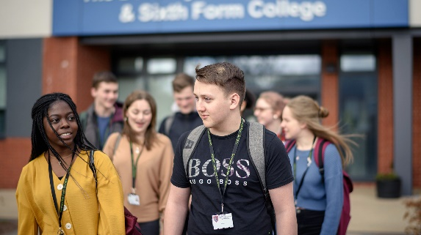 | Sixth Form Bridging Units - The Deanery  www.deanery.wigan.sch.uk
Stay safe, and if you've any more questions about Media Studies, or Sixth Form in general- please drop me an email.

Thanks
Mr Nestor

