English Literature Email to Applicants (Mrs Allan)

Good Afternoon,

We are delighted that you have taken an interest in studying A-Level English Literature at the Deanery Sixth Form College. We are proud to have a consistent 100% pass rate, an increasing number of students achieving higher grades and, as a college, the highest “value added” for students completing academic subjects (such as English Literature) of any college in the Wigan area. We are looking forward to you being a part of our future success.

As you now find yourself in the unprecedented situation of continuing your studies at home, we would like to offer you the benefit of making some preparations for your course by accessing the English Literature Bridging Unit, specifically tailored to support you in beginning our A-Level English Literature course.

This can be accessed at http://www.deanery.wigan.sch.uk/bridging-units/, similarly to the Bridging Units for your other subject choices. If you do happen to want more information, we'd more than happy to give you some tips on how to get a head start on some of the texts, terminology and literary theories that we will be studying once we begin.
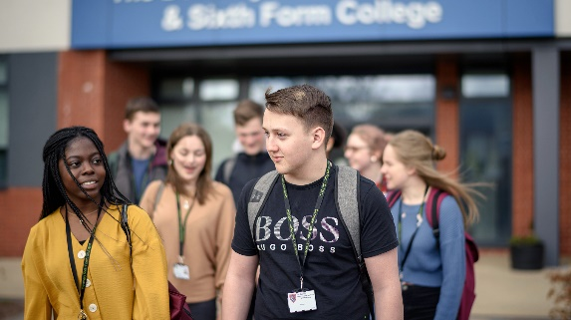 | Sixth Form Bridging Units - The Deanery  www.deanery.wigan.sch.uk
If you've any more questions about English Literature, please do send Mrs Collins or myself an email, and we will be in touch again shortly with some further information and advice on the course.

Take care,

Mrs Allan

